NORTH DEVON MOTOR CLUB
ANNIVERSARY TOUR TO CELEBRATE 80 YEARS
1946 – 2026
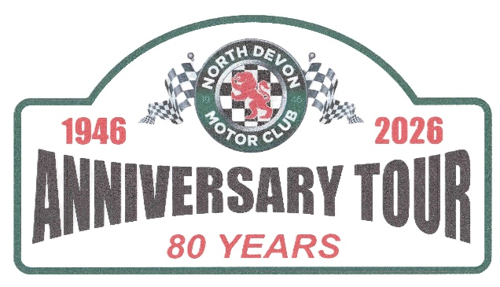
- The 2026 Anniversary Tour is a Touring Assembly for road cars open to members & non-members.
- Motorsport UK Certificate of Exemption No. 207452 has been issued. The event is not a competition.
- The event will take place on Sunday 28th June 2026 starting at 9.00am.
- The event is organised by North Devon Motor Club Ltd. and will start at Gemmas at Waytown, Waytown Farm, Long Lane, Barnstaple, EX31 4NS. What3Words – commended.masterpiece.singing
- The finish venue will be at the club’s own grounds at Sugworthy Circuit, Nr. High Bickington, EX19 8TE What3Words – cackling.unimpeded.rattler
- Entries open with the publication of these regulations and close on 21st June 2026, max entry 50 cars.
- Officials:- Clerk of the Course, John Barthram Tel: 01271 376341, Mob: 07836 386464. Secretary of the Meeting, Steve Parker Tel: 01271 372353 Mob: 07778 203813.
- Entry fee £15 per vehicle of which £10 will be donated to the NDMC Presidents Appeal ‘South West Blood Bikes – serving Devon’.
- Entries must be submitted on the Official Entry Form which is available on the club’s website www.ndmc.org.uk with the entry fee.
- Payment can be made via PayPal or via BACS. Please use reference - 80th
- Entrants will receive a Commemorative Rally Plate (please affix to your vehicle) and easy to follow Route Book which will point out historic locations of the NDMC.
- The route will be approximately 50 miles in length with no controls between start and finish.
- Eligibility of participant’s vehicles – all vehicles must have a valid MOT certificate where appropriate and must have valid insurance in accordance with the requirement of the Road Traffic Act and the relevant law applicable in Great Britain.
- Participants will be required to sign on and register with the organisers at the start venue. Passengers may be carried up to the number for which proper seating is provided in the participant’s vehicle.

- Refreshments at start venue. We thought you might like to start your morning’s tour with some light refreshments and for all to socialise before we set off. We plan to have you at the finish venue by 12.00 mid-day where hopefully you will continue with the day’s celebrations. Breakfast or snacks and tea or coffee are available at the start from 8.00am (tour start from 9.00am). Gemma has kindly opened one hour early just for us so please patronise.

